Title of the abstract (Arial bold 14)
Presenting author 1, co-authors (Times New Roman 10)
enfi2024@jku.at (Corresponding e-mail address) (Times New Roman 10)
¹Affiliation of the authors, Institute, University, Street and number, Postal Code City, Country (Times New Roman 10)
Abstract: The abstract should be maximum 6 lines long and written in a clear way. This will help that attendees that are not really in your field, will find it appealing to listen to your flash presentation and to visit your poster and have an informal talk with you while drinking a cup of coffee together. (80 to 100 words, Times New Roman 10, Justified layout)
Keywords: atomic force microscopy; fusion proteins; nano-particles; liposomes (4-6 words, Times New Roman 10)

Introduction
This is the general introduction into your topic of research. We recommend using a couple of suitable references. To facilitate the type setting of the abstract booklet, please submit your abstract in PDF format. There will be one abstract per page in the abstract booklet. Please stay within the length limit of one A4 page. The Scientific Advisory Board will select the session for which your contribution is most appropriate. (Times New Roman 10, Justified layout)
Results and Discussion
In this section, the results are summarized and figures or tables may be employed (see Figure 1 in the right column). However, simple findings can be presented directly in the text with no needs for tables or figures. You can summarize your scientific results like in a regular journal article, but it is not necessary to go into all possible details. There will be time to go into details during the poster sessions and scientific discussions during EnFI2024.
Please feel free to use equations such as:
(1)
At the end of this text passage, the text is going to wrap due to the two-column layout. Please take care of a symmetrical layout and insert a few blank lines, if necessary, to continue in the new column below the introduction heading on the left side.
References are indicated by following the same style as displayed in this abstract. They should appear numbered by order of mention in text. (Times New Roman 10, Justified layout)

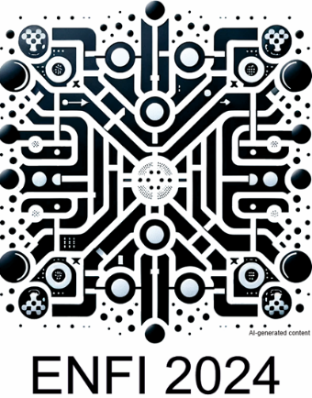
Figure 1: Please give a short description of the figure by writing a clear figure caption. (Times New Roman 10, Justified layout, Italics)
Conclusions
Here you might summarize in a concise way the main conclusions of the work you are presenting and eventually highlight perspectives. (Times New Roman 10, Justified layout)
References
- K. Eersels, P. Lieberzeit, P. Wagner, ACS Sens. 1 (2016) 1171-1187
- C. C. Mardare, A. W. Hassel, Phys. Status Solidi A, 216 (2019) 1900047, doi: 10.1002/pssa.201900047
- A.J. Bard, L. R. Faulkner, Electrochemical Methods, 2nd ed.; Wiley: New York, 2001.
(Times New Roman 9, Justified layout)

Acknowledgements
Please be kind to the sponsors of your work (BMBF, CDG, DFG, FFG, FWF, FWO, FOM, IUP, EU, FP7, etc.) and acknowledge funding. (Times New Roman 9, Justified layout)

